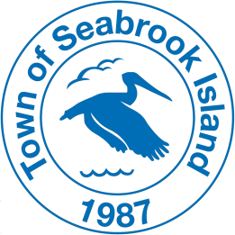
TOWN OF SEABROOK ISLAND
Environment & Wildlife Committee
Regular Meeting (Postponed from April 13, 2023)

MONDAY, APRIL 24, 1:00PM

Virtual Meeting (Zoom)
Watch Live Stream (YouTube)

Participate in the Meeting: Individuals who wish to participate in the meeting via Zoom may access the meeting as follows:

- Instructions for Joining & Participating in the Virtual Meeting

To join by computer, tablet, or mobile device:

- +13092053325, 84423694612# US
- +13126266799, 84423694612# US (Chicago)

Dial by your location
- +1 309 205 3325 US
- +1 312 626 6799 US (Chicago)
- +1 646 558 8656 US (New York)
- +1 646 931 3860 US
- +1 301 715 8592 US (Washington DC)
- +1 305 224 1968 US
- +1 669 444 9171 US
- +1 669 900 9128 US (San Jose)
- +1 689 278 1000 US
- +1 719 359 4580 US
- +1 253 205 0468 US
- +1 253 215 8782 US (Tacoma)
- +1 346 248 7799 US (Houston)
- +1 360 209 5623 US
- +1 386 347 5053 US
- +1 507 473 4847 US
- +1 564 217 2000 US
Meeting ID: 844 2369 4612

Find your local number: https://us02web.zoom.us/u/kdtYbxs5LW

To join by phone: Call (646) 558-8656 *Please note that long distance rates may apply*

- Meeting ID: 844 2369 4612 Passcode: 478467

AGENDA

CALL TO ORDER

APPROVAL OF MINUTES

OLD/NEW BUSINESS

Continued review of the Seabrook Island beach ordinance and discussion on recommended revisions.
This discussion will focus on fires on the beach (allowed now only as permitted by SIPOA). Attending the committee meeting will be Fire Chief Ryan Kunitzer, St. John’s Fire District, to discuss how best to structure an open burning ordinance for the Town of Seabrook Island that could/should include safety restrictions and guidelines for allowing fires on the beach. He also has suggestions for improving enforcement to ensure proper and safe beach fires.

ADJOURN

